GRADE 7 ACCELERATED · UNIT 1 · LESSON 1  Rewriting Numbers in Equivalent Forms  Additional Practice 7A.01.01 | Name_________________________  Date__________________________  Period________________________

1. Which strategy will always work to rewrite a fraction as a decimal? Fill in one bubble.
○ Multiply or divide by 100.
○ Divide the numerator by the denominator.
○ Create an equivalent fraction with a denominator of 100.
○ Use the place value of the last digit to determine the denominator.

2. Which strategy will always work to rewrite a terminating decimal as a fraction? Fill in one bubble.
○ Multiply or divide by 100.
○ Divide the numerator by the denominator.
○ Create an equivalent fraction with a denominator of 100.
○ Use the place value of the last digit to determine the denominator.

For questions 3 through 5, write each fraction as an equivalent decimal. Use bar notation for any decimal that repeats. Then fill in one bubble.
3. | 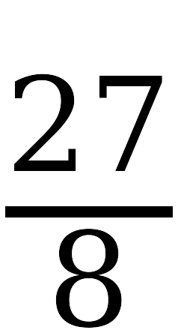 | = ______________________
This is a ○ terminating decimal ○ repeating decimal.

4. |  | = ______________________
This is a ○ terminating decimal ○ repeating decimal.

5. |  | = ______________________
This is a ○ terminating decimal ○ repeating decimal.

6. The decimal equivalent of 59/11 is 5.3636… . Which of these is 5.3636… written in bar notation? Fill in one bubble.
○ A. | 

○ B. | 

○ C. | 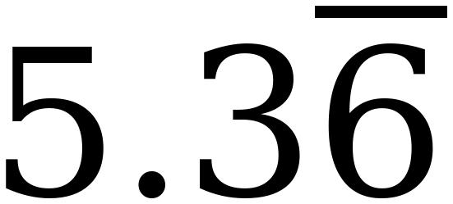

○ D. | 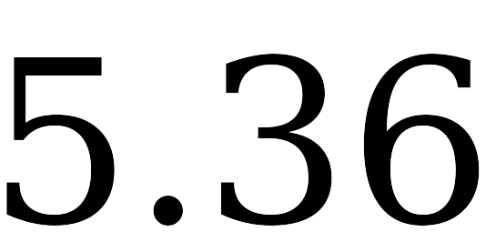

7. |  | = ______________________

Use your answer to question 7 for questions 8 through 10. Predict each decimal equivalent, then check it with your calculator. Use bar notation for every repeating decimal.
8. | 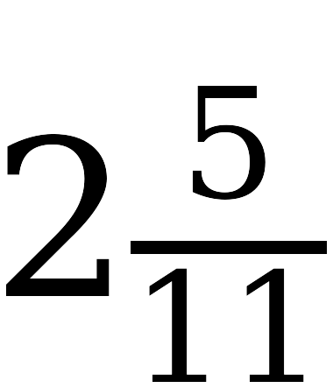 | = ______________________

9. |  | = ______________________

10. Use 87/11 for parts a and b.
a. Write 87/11 as a mixed number. ____________________
b. Write 87/11 as a decimal. Use bar notation. ____________________
11. Dominic divides 1 by 6 on his calculator. The screen shows 0.166666667 .
a. Is 1/6 a terminating decimal or a repeating decimal? Fill in one bubble.
○ Terminating.
○ Repeating.
b. Write 1/6 in bar notation. ____________________
c. Explain why the last digit on the screen is a 7.

